Triangular Trade Web Quest

Name_________________ Period_________

**Click on the link below and watch the video then answer the question in the space below. Please use sentences. ☺**

[**https://www.youtube.com/watch?v=wiBAb8-gQZw**](https://www.youtube.com/watch?v=wiBAb8-gQZw)

***Question:*** *Summarize what the commentators share in this clip about the slave trade in early American history.*

**Read the information below. Then, on the map, draw the routes and label the goods on each route that are exchanged.**

**Triangular Trade - The Slave Trade**  
Slavery had existed in Africa since ancient times. Enslaved Africans became part of the international trade network of the period used extensively by the Spanish and the Portuguese in the Americas. The English became involved with the Slave Trade and the pattern of Triangular Trade across the Atlantic was formed. Sir John Hawkins is often considered to be the pioneer of the British slave trade, because he was the first to run the Triangular trade route across the Atlantic, making a profit at every stop.

**Triangular Trade - The Trade Routes**  
Triangular trade is a term that describes the Atlantic trade routes between three different destinations, or countries, in Colonial Times. The Triangular Trade routes, covered England, Europe, Africa, the Americas and the West Indies. The West Indies supplied slaves, sugar, molasses and fruits to the American colonies. The Triangular Trade Routes included the following:

* Leg 1: Ships from England would go to Africa carrying iron products, cloth, trinkets and beads, guns and ammunition. The ships traded these goods for slaves, gold and spices (pepper)
* Leg 2: Ships from Africa would go to the American Colonies via the route known as the 'Middle Passage'. The slaves were exchanged for goods from the Americas, destined for the Slave Plantations
* Leg 3: Ships from the Americas would then take raw materials back to England. The English would use the raw materials to make 'finished goods'
* And the same process would start all over again...

***The Slave Trade starting in Africa***

**Triangular Trade - Goods *from* England**  
The goods that needed to be brought into the colonies from England included manufactured products such as guns, cloth, furniture and tools. Other items such as tea and spices were also sent to the colonies.

**Triangular Trade - Goods *to* Africa**  
The goods that needed to be brought from England to Africa included iron products, cloth, trinkets and beads, copper, guns and ammunition.

**Triangular Trade - Goods *from* Africa**  
Slaves were the most important 'commodity' sent from Africa. Other goods were exported from Africa including spices, gold, ivory and feathers - but these items were destined for Europe via other trade routes.

**Triangular Trade - Goods *to* England**  
The goods that needed to be brought into England from the colonies consisted of raw materials from natural resources found in the New World such as timber, fur, iron, fish, whale oil, sugar, tobacco, rice and cotton. Rum was one of the few 'finished goods' that were sent to England.

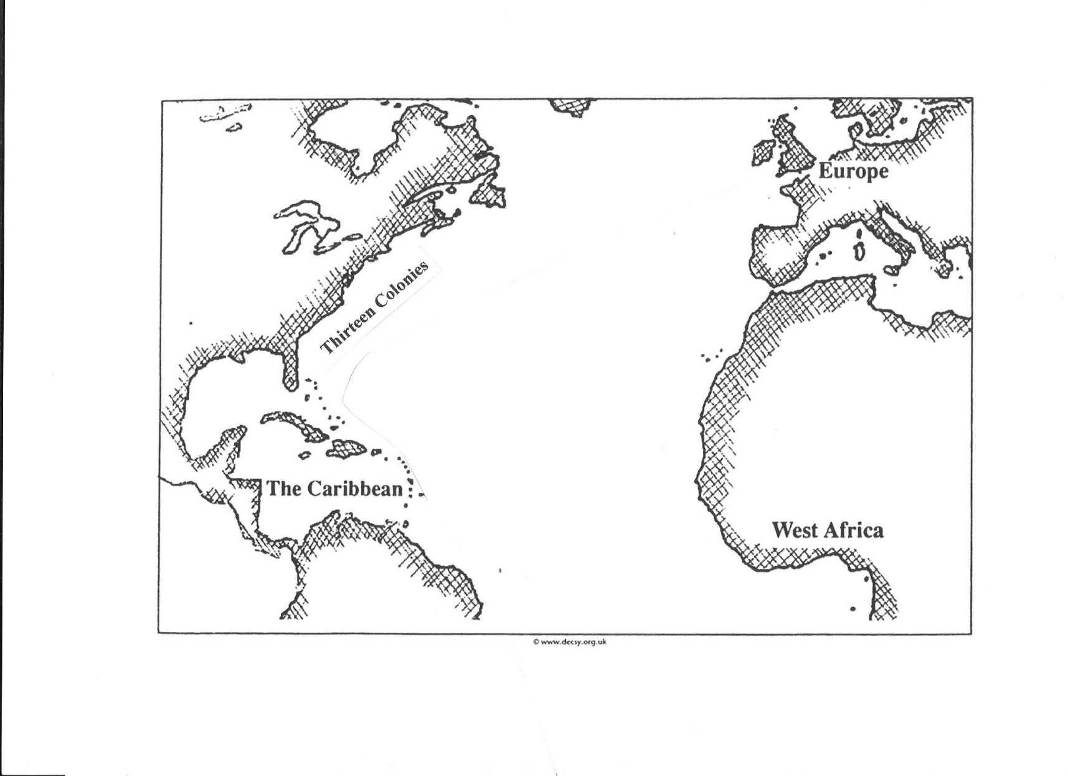

***Question:*** *Looking at the map you filled out, what can you infer about mercantilism (the belief in the benefits of profitable trading) during this time? What can you infer about the role Africa played in the triangular trade?*

Click on the link below. Then, click **“Timelines of Estimates.”** Above the chart, select **“Tables”.** Change the drop-downs above the table to **“50 year periods”** and **“Embarked/Disembarked”** (leave the middle drop-down at “Flag”),then click **“Update.”** Use the chart to answer the questions below. ☺

<http://www.slavevoyages.org/>

*What country received the highest number of slaves? ____________________________*

Look at the “Embarked/Disembarked” numbers for the different regions.

*What do you notice? ___________________________________________________________________________________________*

*What does the difference between embarked and disembarked indicate?*

*___________________________________________________________________________________________*

*When was the peak of the slave trade in North America?_____________________________________*

Click on the following link. Take several minutes to examine several photographs, then answer the questions below.

<http://www.slaveryimages.org/s/slaveryimages/item-set/51> (click on images to enlarge)

*What are 3 observances you made from the photographs?*

___________________________________________________________________

___________________________________________________________________

___________________________________________________________________

*There were a few revolts on slave ships, but not a lot. What are 2 reasons you think this might have been. Use the photos as the basis for your answer. Please use complete sentences to explain. ☺*

______________________________________________________________________________________________________________________________________________________________________________________

______________________________________________________________________________________________________________________________________________________________________________________

*What is 1 question you still have after this web quest?*

___________________________________________________________________________________________